**Lead and Copper concentration in tap water (NYC)**

**Data Source**

The Data for this Project was taken from <https://data.cityofnewyork.us/Environment/Lead-At-The-Tap-Results/kdqv-qs7p>

Data Source Provided by: Department of Environmental

**Data Normalization**

The Data obtained was not normalized and needed to be normalized before analysis.

Following steps were taken to normalize the data.

1. Duplicate Values were removed.
2. Boroughs were sub divided in initial data, they were categorized into 5 main value.

**Data Visualization**

While visualizing the data I focused on finding trends and data distribution to find solutions to following problem statements.

1. What is the Avg. lead and Copper concentration across different boroughs in NYC?
2. Which Zip codes recorded the unsafe concentrations of Lead (50mg/L) and Copper (1.3 mg/L)?
3. Month wise Lead and Copper concentrations of the past 3 years.

**Conclusions**

1. Highest avg. of Lead concentration in tap water recorded is of Staten Island, while least concentration is observed in Manhattan.
2. Highest avg. of Copper concentration in tap water recorded is of Brooklyn, while least concentration is observed in Queens.
3. Highest avg. of Lead concentration in tap water recorded is in the month of June.
4. Highest avg. of Copper concentration in tap water recorded is in the month of Feb.

**Next Steps**

1. Comparison of lead and copper concentration based on tap water source.
2. Dynamic usage of Tableau parameters to give user more interactivity.

**Dashboards**

1) Lead Stats ( Filter Capability : Year )

* Avg. Lead mg/L per borough
* Unsafe Lead level(50 mg/L) per zip code
* Avg. Lead mg/L per Month

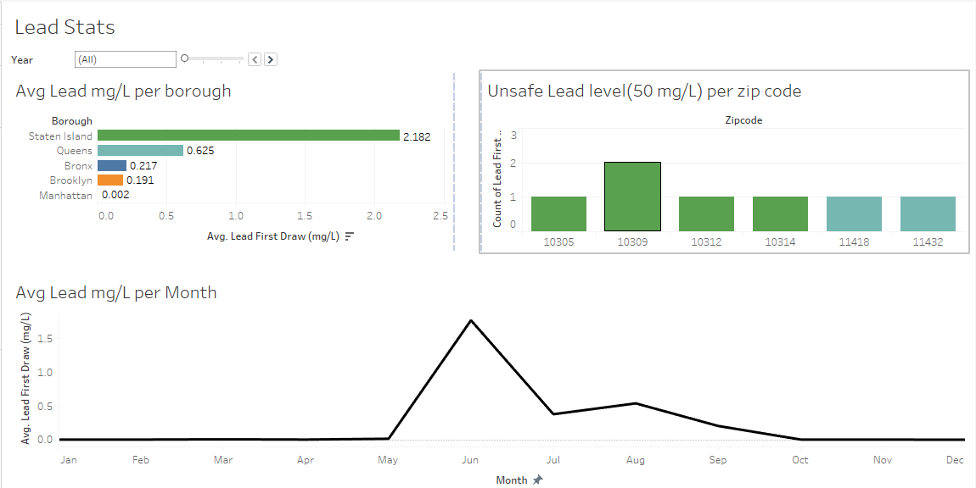

2) Copper Stats ( Filter Capability : Year )

* Avg. Copper mg/L per borough
* Unsafe Copper level(50 mg/L) per zip code
* Avg. Copper mg/L per Month

